***Retail Sales Forecasting***

**Aim:** Forecast furniture sales in a retail superstore using time series data. Understand components, apply forecasting techniques, and visualize insights for accurate predictions and inventory management.

***Introduction:***

In the dynamic retail landscape, predicting furniture sales plays a pivotal role in maintaining inventory balance. This project delves into time series data, examining components and employing forecasting techniques for precise sales predictions. Through effective visualization, the goal is to equip the retail superstore with actionable insights for optimal inventory management and enhanced customer experience.

**Key Steps:**

1. **Understanding Time Series Data:**

First task is understanding the time series dataset.

* 1. ***Importing Dataset***:

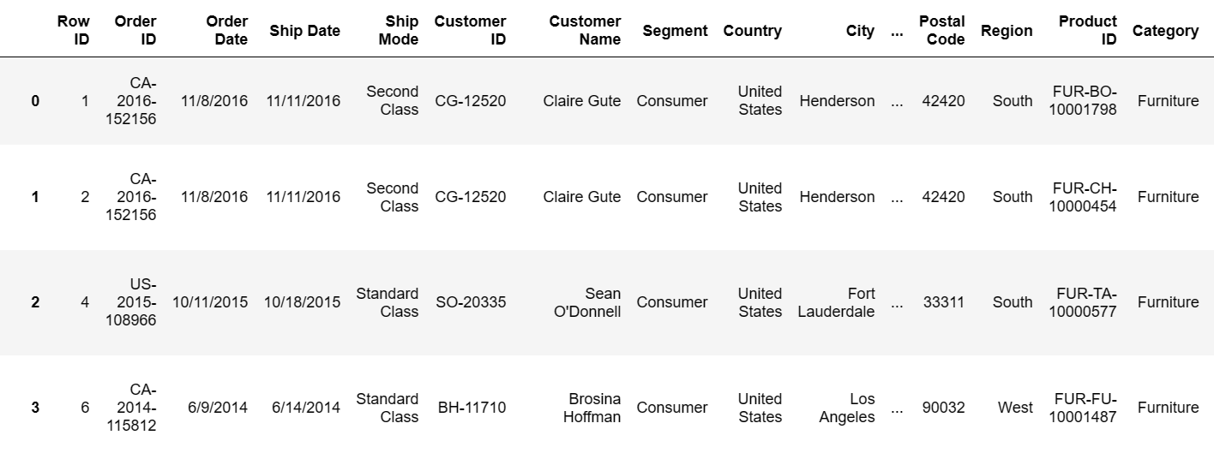

***Fig 1.1: Importing and Seeing Dataset***

* 1. ***Handling Missing Values***:

Next task is to see the missing values in the dataset.

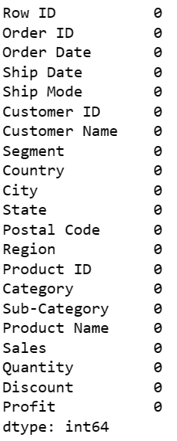

***Fig 1.2 Missing Values in Dataset***

* 1. ***Descriptive Statistics of Dataset***:

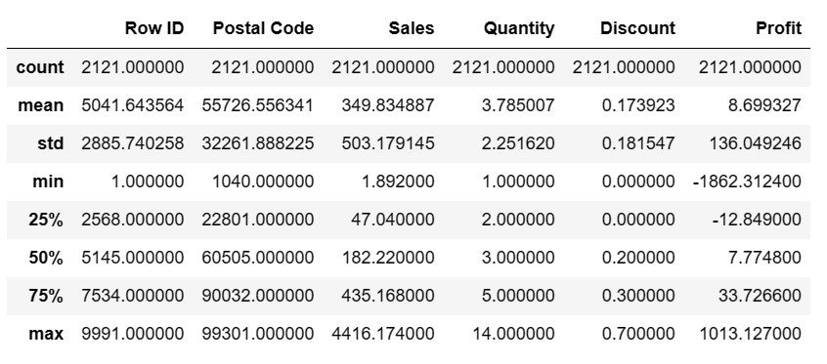

***Fig 1.3 Descriptive Statistics of dataset***

1. **Checking Components of Time Series:**

Identifying and analyzing the various components of time series data, such as trends and seasonality.

1. **Trends:**

* Trends in time series data reveal long-term patterns or changes over time.
* Identifying trends involves using methods like moving averages or regression analysis to smooth out short-term fluctuations and highlight overall direction.

1. **Seasonality:**

* Seasonality refers to repeating patterns in data at regular intervals.
* Techniques like decomposition and autocorrelation analysis help detect and analyze seasonality, providing insights into periodic influences on the time series data.

***Fig 2.1 Components of Time Series Data***

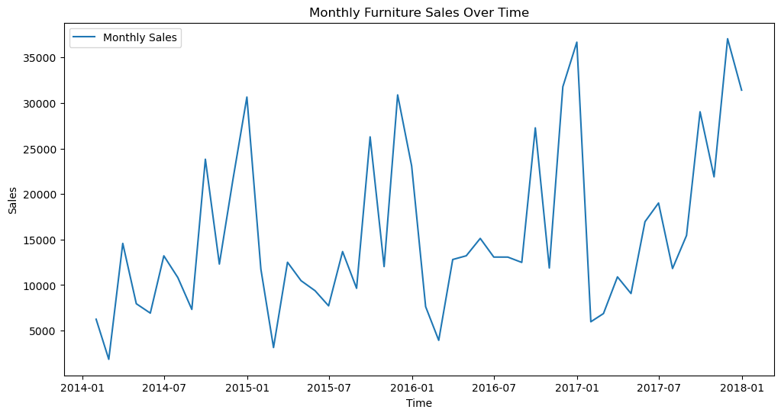

1. **Forecasting Techniques:**

**3.1 ARIMA: Autoregressive Integrated Moving Average**

* Autoregressive (AR):
  + - AR component captures the relationship between an observation and its past values.
    - It signifies the influence of previous time points on the current one.
* Integrated (I):
  + - The I component involves differencing the time series data to make it stationary.
    - Stationarity ensures a constant mean and variance, simplifying modeling.
* Moving Average (MA):
  + It accounts for short-term fluctuations not explained by the autoregressive component.

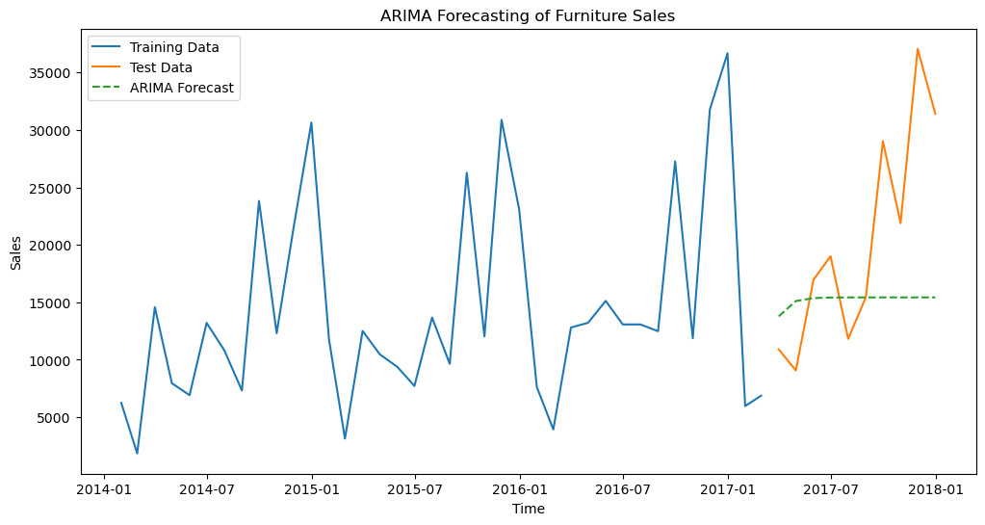

***Fig 3.1 ARIMA Forecasting***

* 1. **Hyperparameter Tuning:**

The best Parameters and the lowest mse is:

***Best ARIMA Model Order: (0, 2, 2)***

***Root Mean Squared Error (RMSE): 8301.571605452114***

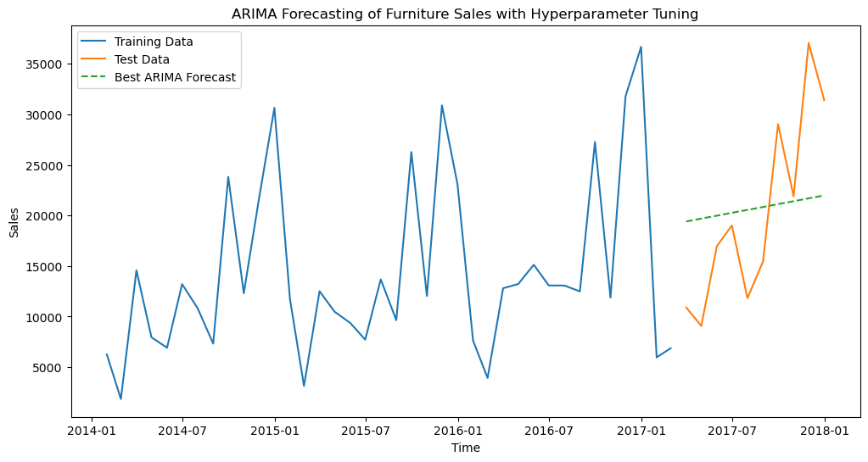

***Fig 3.2 ARIMA Forecasting with Hyperparameter Tuning***

1. **Visualization in Time Series:**

Visualizing the trend and seasonality of this dataset.

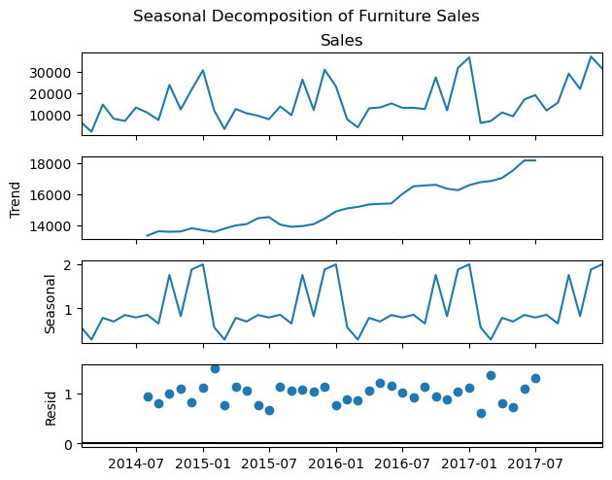

***Fig 4.1 Visualization of time series data***

***Interpretation:***

* ***Top Subplot:*** Represents the observed time series.
* ***Second Subplot:*** Illustrates the trend component.
* ***Third Subplot:*** Displays the seasonal component.
* ***Bottom Subplot***: Shows the residual component.

***Project Resources***

**ARIMA Forecasting:** [Python | ARIMA Model for Time Series Forecasting - GeeksforGeeks](https://www.geeksforgeeks.org/python-arima-model-for-time-series-forecasting/)

**GitHub Repository:**

Codes related to this project can be seen at my GitHub Repository:

GitHub Repository: [Retail Store Forecasting](https://github.com/madhurimarawat/Machine-Learning-Projects-In-Python/tree/main/Sales%20Forecasting%20for%20Furniture%20Store)